mill

December 9, 2020

Sylvia Chelf
Army Corps of Engineers
5905 Lewis Center Rd.
Lewis Center, OH 43035-9215

Dear Ms. Chelf:

Thank you for offering BE the opportunity to assess the food service needs at the Army Corps of Engineers at Alum Creek Lake. Unfortunately, The Bureau of Services for the Visually Impaired (BSVI), Business Enterprise Program (BEP) elects to decline the opportunity to provide these vending operations at this time.

Please accept this letter as an official waiver of the aforementioned operations. Upon the expiration of any subsequent contracts for food service BSVI/BEP should be notified so that the suitability of the location(s) can be re-evaluated. This exclusive notice of waiver shall not serve as a waiver of the priority afforded BSVI and the Business Enterprise Program by Ohio Revised Code 3304.30 et seq. BSVI looks forward to a continued partnership with the Army Corps of Engineers to support suitable opportunities for blind operators.

Once again, thank you for the opportunity to discuss your food service options.

Sincerely,

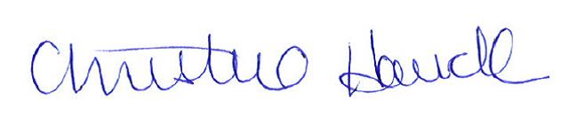

Christine Hauck/sn
Business Enterprise Program Manager

Ec: Sally Nunes, BE Area Manager
Jeff Tolle, OVRC Representative
Annette Lutz, OVRC Chair
BEArchive
File

